Name of Society
Assessed by (your name) |  | Date
Is this Risk Assessment covering your core activity or a one off activity?
Additional Event Details (inc. location, date and activity)

HAZARD CHECKLIST – this is not an exhaustive list, tick those that apply
Unsure about what hazards are associated with your activity? The SU can help; email them with full details of your planned activity and the SU can fill in this section, after which you can continue analysing the consequences and control measures.
Physical Hazards |  | Environmental/Biological Hazards |  | People Centred Hazards
Fire or Fire Alarm |  | Weather (heat or adverse) |  | Sporting or physical activity
Overpowered electrical outlet |  | Uneven ground or terrain |  | Differing experience levels
Faulty electrical equipment |  | Loud noise |  | Bullying, harassment and discrimination
Open flames |  | Bright light |  | Anti-social behaviour
Trips, Slips and Falls (inc on spillages) |  | Temperature |  | Health Emergency (eg. asthma attack)
Manual Handling |  | Food Poisoning
Travel |  | Allergies (food, materials or animals)
Working at height |  | Alcohol
Mess
Emergency at external venue
Tools (eg. Needles, scissors, knives)

Any additional hazards not listed?

1. IDENTIFY HAZARDS | 2. WHO MIGHT BE HARMED & HOW? |  | 3. CALCULATE THE RISK |  |  | 4. DECIDE ON PRECAUTIONS | 4. RESIDUAL RISK RATING
Hazard (from checklist and additional) | Who might be at harm?  Students, visitors, staff, passer bys | How might they be harmed?  What type of injury? How severe? | Level or risk before control measures  See risk matrix on last page |  |  | What controls are in place to reduce likelihood or severity, and therefore risk? | What is the risk after control measure are in place? (calculate again)
Hazard (from checklist and additional) | Who might be at harm?  Students, visitors, staff, passer bys | How might they be harmed?  What type of injury? How severe? | Likelihood | Severity | Risk |  | Likelihood | Severity | Risk

Signed By:
Approved by *SU use only*
Approval Date: *SU use only*

Risk Matrix
A hazardous event has a likelihood of happening and the consequence has a severity of injury. You use these two factors to calculate the level of risk with the below risk calculator.
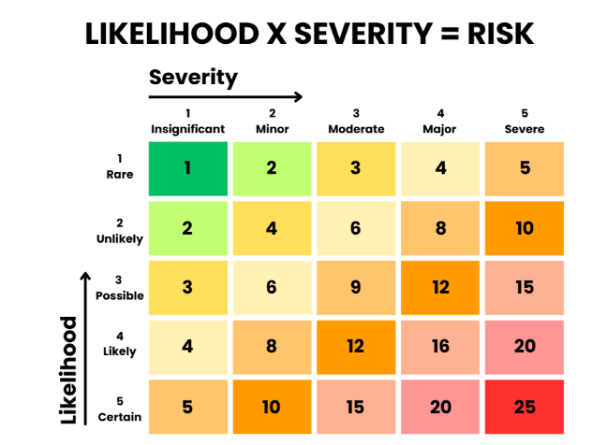
For example, if the likelihood of someone tripping during a social event in the SU Lounge is 3 - Possible, and the severity of injury could be 4 - Major, the risk is 12.
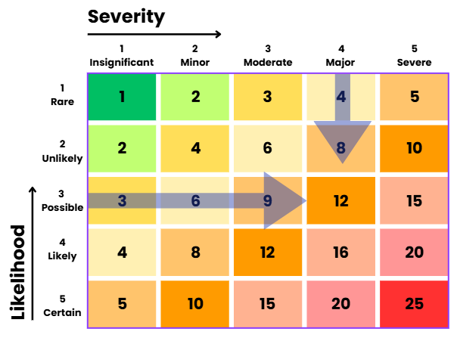
When estimating the severity and likelihood, think about what is not an unreasonable possibility. You can use the below guidelines to help you understand severity:
Insignificant - first aid injury, such as minor cuts or bruises
Minor - short term injuries, such as cuts that require stitches
Moderate - significant longer term injuries, such as broken bones
Major - permanent life changing injury, such as brain injuries or severance
Severe - death
And the following to understand likelihood:
- Minimum Likelihood: Will almost never occur (Around 0.01%).
- Low Likelihood: Will seldom occur (Around 0.1%).
- Medium Likelihood: Will sometimes occur (around 1%).
- High Likelihood: Will frequently occur (around 10%).
- Maximum Likelihood: Certain or almost certain to occur (100%).

